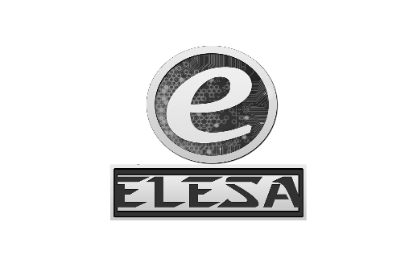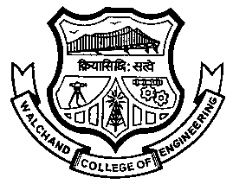WALCHAND COLLEGE OF ENGINEERING, SANGLI

**ELESA**

**ELECTRONICS ENGINEERING STUDENTS’ ASSOCIATION**

DATE:

To

Dr. B. G. Patil,

Dean Students’ Welfare

WCE, Sangli.

**Subject:** Regarding funds for ELECTROVERT 2016 under the “**Lead College Scheme**”

Respected Sir,

ELESA has conducted its mega event “ELECTROVERT 2016” (A state level technical Symposium) on 17th and 18th September, 2016.

ELECTROVERT was comprised of following sub-events:

1. CircuTron - Circuit building competition

2. Procurro - Project presentation competition

3. µ-REKA - 8051 & 8085 programming competition

4. Proteygon - Circuit design contest in Proteus

5. Tractatus – Management Event

6. Auxesis - F.E. special event

7. Reflux - Paper Presentation Competition

8. Quizonic – Quiz Competition

9. e-CHAMP – Embedded System Designing Competition

10. Funnably – On the spot event

So we request you to consider our application and provide us funds.

Dr. S.D. Ruikar, Mr. Amol Gaykhe,

Staff Advisor, ELESA President, ELESA

Approved By:

**HOD,**

**Dept. Of Electronics**

Dr. B. G. Patil

**Staff Advisor**

Dr. S. D. Ruikar

**President**

Amol Gaykhe

*president@elesa.in*

**Vice-President**

Pavan Chopade

*vicepresident@elesa.in*

**Event Director**

Rukkaiyya Shekh

*event@elesa.in*

**Technical Director**

Vidya Mane

*technical@elesa.in*

**Club Service Director**

Tejashree Chougule

Saraswati Solage

*csd@elesa.in*

**Web Developer**

Narsing Mundhe

*webadmin@elesa.in*

**Treasurer**

Samrudddhi Kulkarni

*treasurer@elesa.in*

**Aptitude Developer**

Tejashree Chougule

Saraswati Solage

*aptitude@elesa.in*

Dr. P. J. Kulkarni,

Deputy Director,

WCE, Sangli

Dr. B. G. Patil,

HOD, Electronics Dept,

Dean Students Welfare

Dr. G. V. Parishwad,

Director,

WCE, Sangli